Understand Search Algorithms:

* Linear Search:
  + Scans each element one by one.
  + Best when the list is unsorted or small.
  + Time Complexity:
    - Best: O(1)
    - Average: O(n), Worst: O(n)
* Binary Search:
  + Works only on sorted lists.
  + Repeatedly divides the list and compares.
  + Best for large, sorted datasets.
  + Time Complexity:
    - Best: O(1)
    - Average/Worst: O(log n)

Analysis:

|  |  |  |
| --- | --- | --- |
| Algorithm | Time Complexity | Suitable When... |
| Linear Search | O(n) | List is unsorted or very small |
| Binary Search | O(log n) | List is large and sorted |

Use Linear Search when:

* You don't have time to sort.
* Data is small and updated frequently.

Use Binary Search when:

* You can keep the list sorted.
* Performance is important for large data.

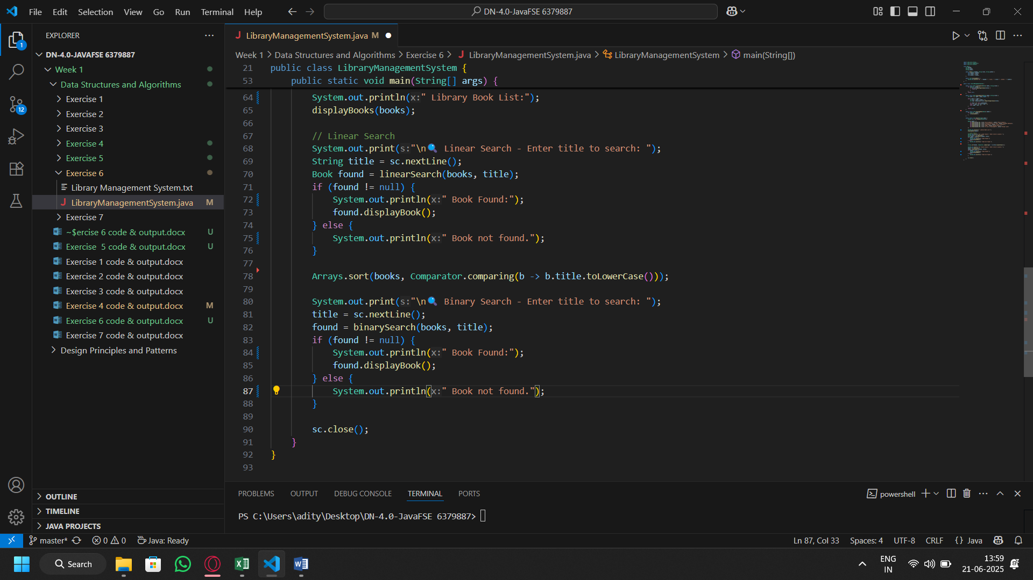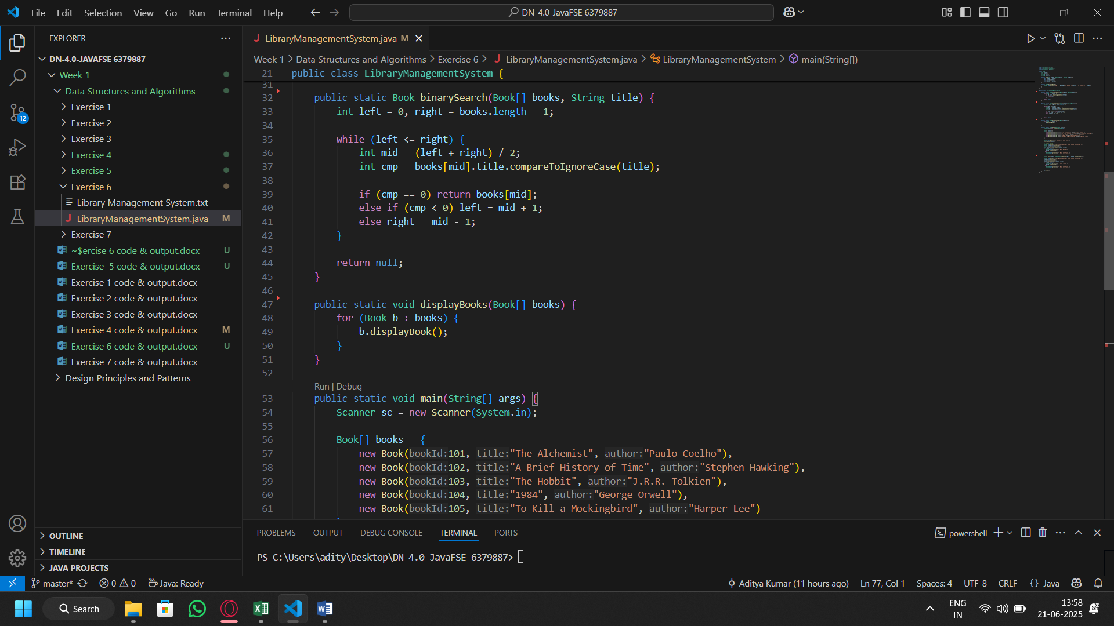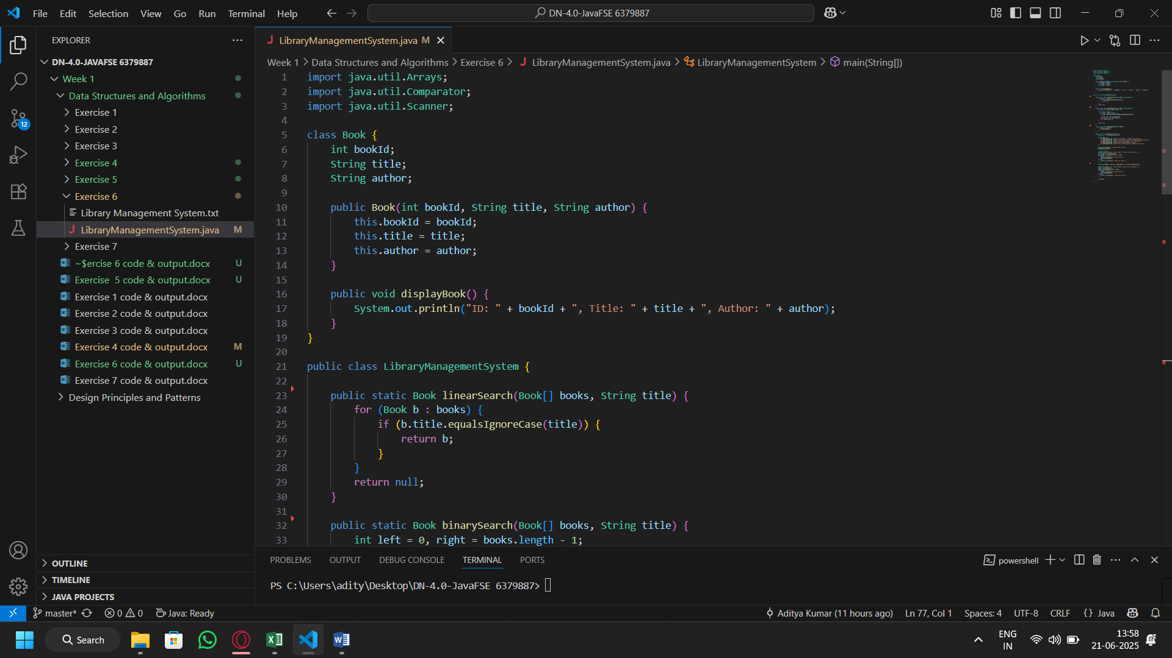Code:

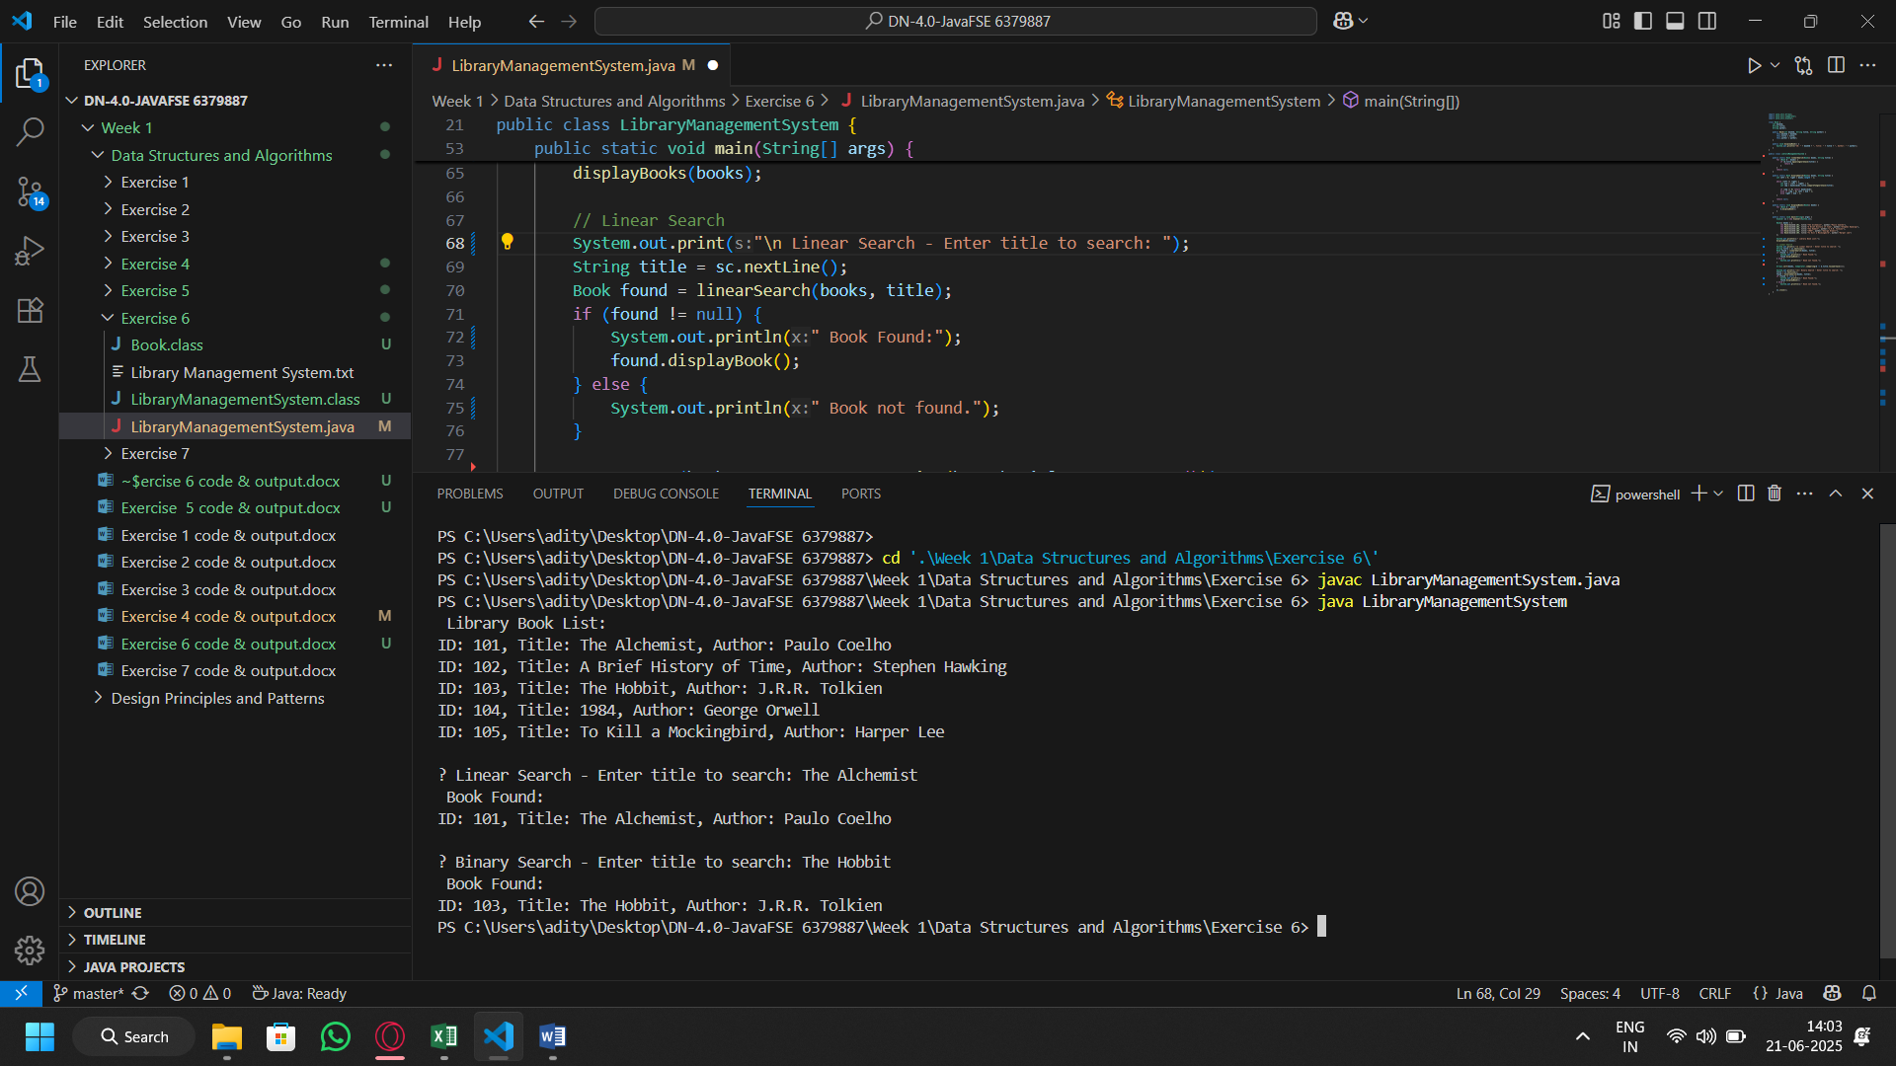Output: